RE- This term, we will be focusing on Christianity and how symbols in the Bible, the story of Jesus’ baptism and the church relate to nature of God.

Geography- We will be taking a closer look at where the countries of the world are located. We will locate and describe places using longitude and latitude, developing an understanding of time zones and find about specific areas of the Earth including the Equator, the Hemispheres, the Poles and the Tropics.

Science- This term, we will be finding out electricity! We will be learning how a circuit must be complete to allow the electricity to travel all the way around it, and even create our own circuits.
.
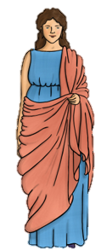
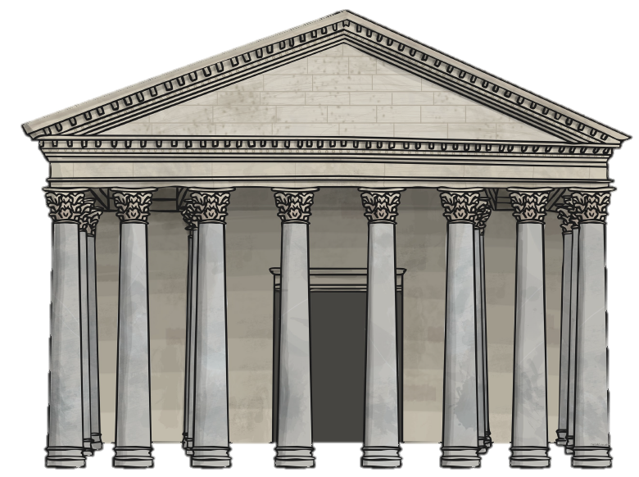
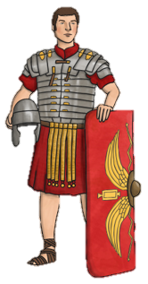
ICT- This term Swans will be focusing on our digital literacy in a range of ways. As we continue to discuss the aspects of safety online, we will also be comparing and designing our own elements that could be found online. ICT will also become a part of our History sessions as we focus on researching information more independently, filtering through to relevant information.

Music- Music will continue to be taught by Karl. The children will experience a range of music using their listening skills as well as learning to play simple tunes on a variety of instruments including a ukulele!

French- This term we will learn about the shopping experience in France. Children will learn specific vocabulary of fruit, vegetables and clothes. They will also learn key phrases for asking the questions needed when going shopping.

Design and Technology- We will be designing and creating a Roman sprung catapult using levers that is fit for a soldier to use. We must consider the materials used and the manufacturing process, as well as functionality.

Maths – Over the term, we will be consolidating our multiplication and division knowledge before moving onto learning about fractions and decimals. Children will learn to add and subtract fractions, as well as converting these into decimals. We will be able to confidently use a place value chart to hundredths!
Road to Rome!
English- Our English lessons will be fit in perfectly with our topic of the Romans by using ‘Escape to Pompeii’ as our main theme. The children have become confident in using a variety of language techniques in their writing and choosing different sentence structures; therefore, they will now begin to apply this in all of their writing. We will become journalists to create our own newspaper report on the eruption of Mount Vesuvius.

History- Our topic focuses on the impact of the Romans on Britain therefore we will develop a deep understanding of the power of the Roman army and evaluate its effectiveness. This will include a deepened understanding of the armour they wore and the structure of the army. We will also look at the cultural aspects of the Romans that changed Britain, including its architecture and music, as well as their religious beliefs. The topic will also cover Boudicca’s rebellion, in which the children will engage in discussion about how successful they think the rebellion was and why.

PE- We will continue with Mr. Mooney this term to develop our physical skills. Through dance and basketball, we will be focusing on our own abilities and the control we have over our bodies.

Art and Design- This term in Art, we will be exploring still life by observing various tones to capture 3D form in 2D. By mixing colours and considering lighting, foreground and background, we will be painting a range of fruit!

