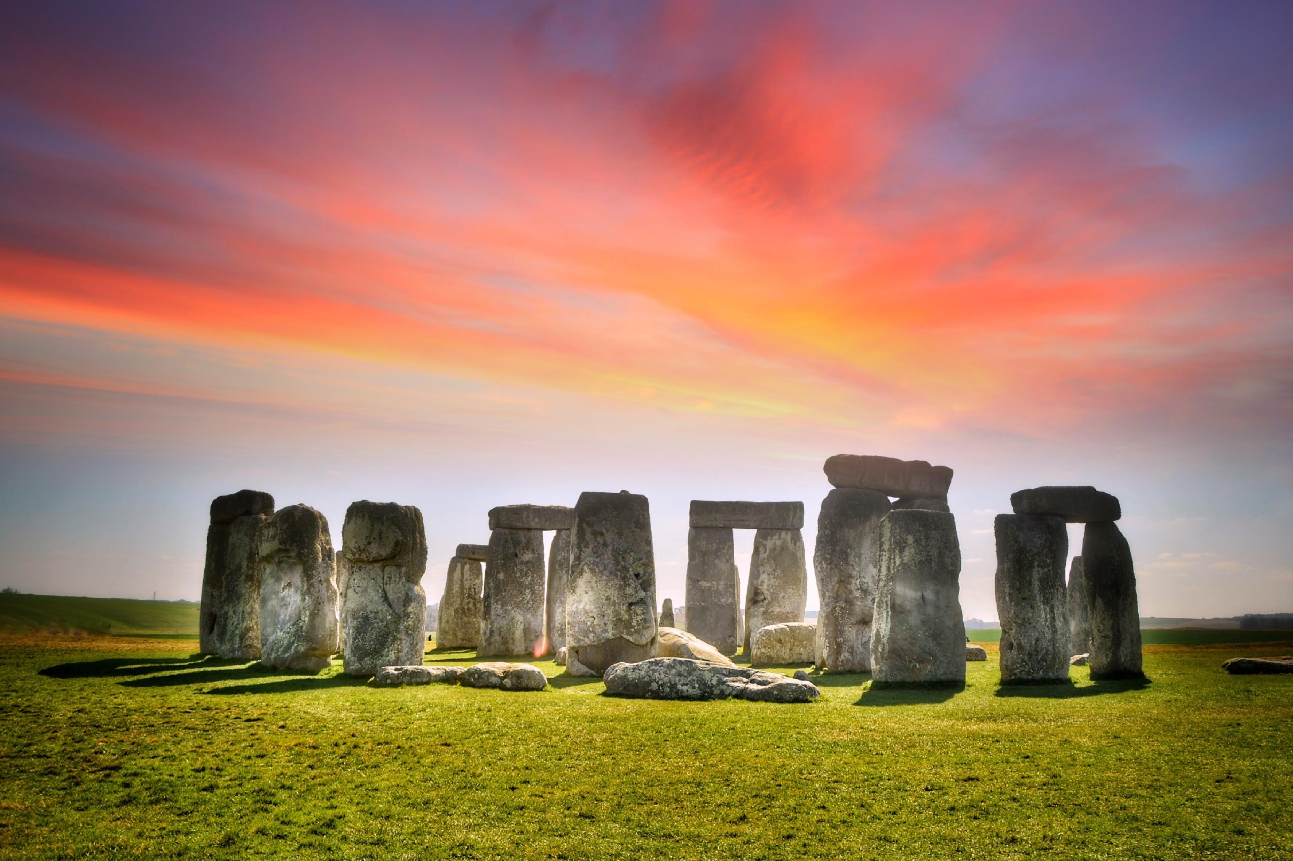
v
PE
In PE children will be taking part in group games on Monday and Friday to improve teamwork with invasion skills and games, as well as improving our skills in gymnastics.
English
This term we will be creating detailed and imaginative descriptions inspired by the ‘Stone Age Boy’ book. We will begin to use subordinating clauses to add detail or context to our work and expand our use of coordinating conjunctions throughout our work. We will also be using descriptive language to recount events from ‘Stig of the Dump’.

Music
In music we focus on our musical skills. We will practise a range of skills, learn new vocabulary and work hard on our listening skills to unpick how music is made and how it makes us feel.
Science:
This term we will be looking closely at the importance of the digestive system. We will learn the names and functions of each part of the system and be able to identify the different types of teeth in humans and their purpose.
We will also learn to compare and group materials according to whether they are solids, liquids or gases.
Maths
This term we will be focussing on our understanding of numbers and place value. Swans will be thinking about each digit in larger numbers and using this knowledge to help then add and subtract much larger numbers using the column method. As well as our written methods, Swans will also have a large focus on their mental maths skills, working daily to practise every times table up to 12 x 12!
Art
Children will discover how to make drawings that capture a sense of drama using charcoal in relation to our topic. This term, we will be creating cave style drawings.

ICT
In ICT this term we aim to improve our digital literacy. We will be completing a series of tasks building upon what we have learned so far. We will be working on our skills when using Microsoft Office Applications.
RE
This term in RE we will be looking at the basic beliefs and practices of Islam, and show respect and understanding towards the followers of Islam.

PSHE
Children will be exploring the choices that we can make about looking after our bodies. The lessons look at making safer choices about their bodies, sleep, exercise, cleanliness and diet.

French
We will be developing our intercultural understanding by being introduced to the sights of some typical French cities. We will also learn to describe places in a town, count to 100 and give our address in French.
History
We will be taking a trip through time from the Stone age to the Iron Age. We will be breaking down each era in detail, thinking about many aspects including clothing, housing, wildlife and the ways that each era changed over time. This will encompass many of our other lessons, tying many ideas together through all of our subjects. Swans will then finish by comparing the Iron age with the Stone Age as well as with their own lives, thinking about what is the same and what is different.
Sticks and Stones

