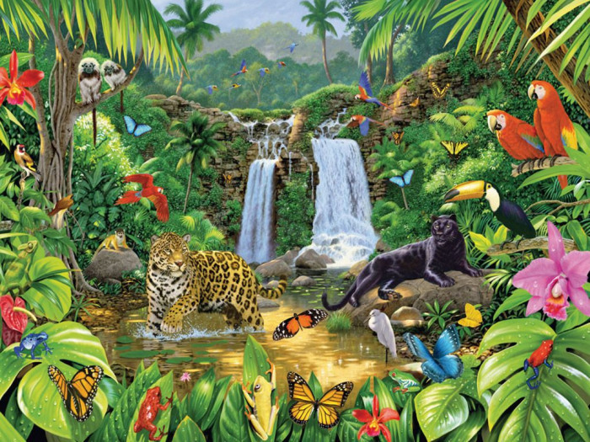
RE - This term, we will be focussing our attention of the religion of Judaism and understanding the key beliefs that Jews put into practice.

History- History this term looks at the Anglo-Saxons and Vikings and their achievements. We will explore life in England after the fall of the Roman Empire and the reasons why the Anglo-Saxons travelled to England’s shores and decided to settle. This moves on to finding out how England was ruled during the settlement of the Anglo-Saxons and how they kept control of the 7 different kingdoms across the land.

Science- During this unit of work, children will learn to recognise the seven life processes common to all living things. They will learn to sort living things using a variety of criteria and extend their use of scientific vocabulary to describe features and characteristics of animals and plants. They will conduct a local habitat search and learn to identify unknown living things using a classification
key. Children will consider how environmental change impacts the local area and suggest ways in
which humans can prevent further damage.
English – Over the summer term, we will be writing a selection of pieces to entertain an audience through the use of setting and character descriptions, poetry and persuasive posters. We will begin to explore using similies and metaphors within our writing, and play around with making objects come to life using personification

Geography - This unit on Water introduces children to the water cycle and allows them to explore the processes of evaporation and condensation through a range of practical activities. By considering water as a finite resource, they are introduced to the ideas of conservation and consider some of the issues surrounding supplying clean drinking water to a growing global population.

Maths – This term we will learning our remaining new topics before consolidating our year of learning, focussing on areas that we have identified that need more attention. Our topics include money, time, shape and statistics.

ICT – This term we will be continuing to focus our ICT skills and develop our digital literacy. This will include the use of both iPads and laptops, using more programs and apps to help with our learning.

French – This term, we learn how to tell the time: o’clock, half past, quarter past and quarter to. We will learn how to read timetables and TV schedules. We will also be looking at holidays, weather and seasons, sports and hobbies.
Music - We are very lucky to continue to have our specialist music teacher come into school each week. This term he will be assisting us to project our voices.

Art and DT – This term in Art, we will be making ‘plinth people’ of characters from our chosen book. In DT, we shall be designing and creating a playground for an animal linking to our topic. We will be including tunnels, perches and even a lighting system!

Fur, Feathers
And Fangs
PE- We will continue to work with Mr. Mooney on our physical fitness. Our focus this term will be athletics, covering a range of outdoor fitness topics to improve our health and stamina for exercise.

