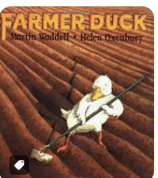
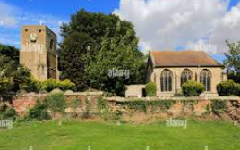
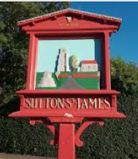
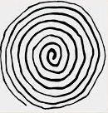
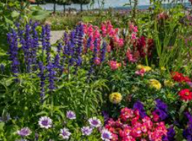
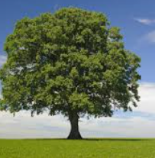
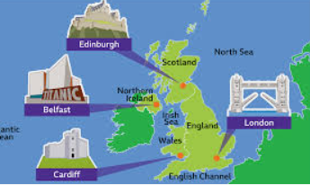
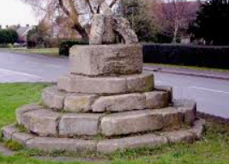
Art/DT
In Art, we will be looking at spiral art.
We will look at how we can control the lines we make by being aware of how we hold a drawing tool, how much pressure we apply, and how fast or slow we move. We will look at how we can draw from observation or imagination. We will learn that we can use colour to help our drawings engage others.
In DT, we will be looking at using moving parts to make our Christmas cards,

PE
This term pupils will explore the fundamental skills of balancing, running, changing direction, jumping, hopping and skipping. Pupils will work collaboratively with others, taking turns and sharing ideas through fun multi-skills type activities. Pupils will develop balancing, rolling and jumping. They will use these skills individually and in combination to develop sequence work, with others. In indoor PE children will be introduced to Yoga to develop balance, coordination, flexibility and strength.

RE
- This term we will be looking at what Christians and Muslims believe in. We will look at their beliefs and how these beliefs are translated into their everyday life. When studying Islam, we will look at how Allah is described in the Qur’an and what Muslims learn about Allah and their faith through the Qur’an. In Christianity, we will learn What Christians learn and understand about God through Old Testament Bible stories.
We will also look at what stories in the New Testament tell Christians about Jesus.

PSHE/SEAL
In PHSE we will be looking at roles and responsibilities. We will look at what responsibilities we have and how we fit in as part of a community. We will also focus on understanding what community is and how to be a responsible citizen within a community.
There’s NO place like home!
Literacy
The children will be looking at a variety of different aspects in Literacy this term in keeping with our theme.
- We will be learning how to plan our sentences out loud before writing.
- We will be learning how to use capital letters and full stops.
- We will be learning how to form our letters correctly and how to use our phonics knowledge to write words.
- We will also be practicing our formation of letters to help make our handwriting more consistent and legible.
Music
Children will learn about the differences between pulse, rhythm and pitch and to learn how to rap and enjoy it in its original form.
As well as learning to sing, play, improvise and compose with the song ‘ Hey you ‘ , children will listen and appraise other Old-School Hip Hop tunes.

History
The children will be looking into the ways in which Sutton St James has changed over time.
- Children will learn about the ways that farming has changed over the years.
- Children will be able to sequence the way in which Sutton St James has changed in the order that they have happened through recalling events and photo sequencing.
Maths
This term the children will have a focus on number and place value. They will be building their knowledge of addition and subtraction within 10. We will be using number lines and part, part whole models to support this learning. We will also be beginning to look at shape, both 2D and 3D.

Geography
This term in Geography we will be focusing on the local area and how land is used in the village.
We will also be learning about the 4 countries which make up the United Kingdom. We will learn the names of the capital cities in the UK and discover some of their famous landmarks.

Science
- This term we will be looking in and around our school grounds and local area to identify various types of trees and plants.
- We will be thinking about the features that help us identify them and the different parts of plants.
- We will also be looking at the changes that occur as the season changes from summer to autumn and autumn to winter.

